Automated Multi-Environment Deployment

FLOW:
Developer → Git → Jenkins CI → Docker → Docker Registry → Dev environment → Staging → Production

## mkdir devops-multi-env
## cd devops-multi-env
## git init
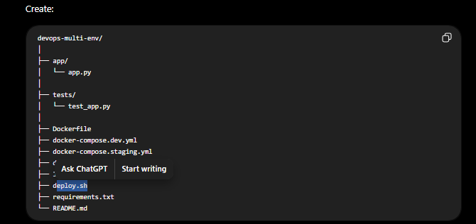
app/app.py
requirements.txt
pip install -r requirements.txt
python app/app.py

DOCKERFILE
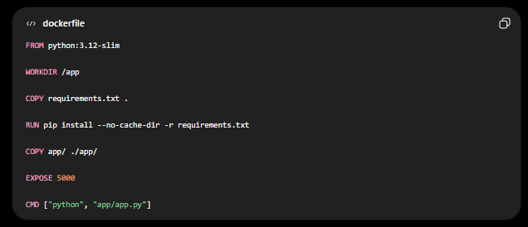

docker build -t devops-app:1.0 .
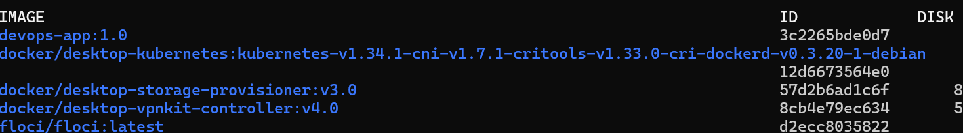
docker run -d --name devops-app-container -p 5000:5000 devops-app:1.0
docker logs devops-app-container
docker stop devops-app-container
Environment configuration
